|  |  |
| --- | --- |
| **Subject** | Software Engineering IV |
| **Subject Code** | **SOE41P1** |
| **Qualification** | Advance Diploma in Information Technology: Application Development |
| **Project/Assignment** | Development of a Portable Power Solution Rental System |
| **Project Deliverable** | Software Requirements Specification (SRS) |
| **Group Members** | Simamkele Mbulawa - **219018413** |
| Amanda Wayise - **219363463** |
| Sinethemba Willie - **220647194** |
| Malixole Pulumo - **206016166** |

Table of Contents

Table of Contents ii

Revision History iv

1. Introduction 1

1.1 Purpose 1

1.1. Scope of this document 1

4. UML Diagrams – This section represents various abstract models of the system i.e. Use Case Diagram, Activity Diagram, Sequence Diagram, Class Diagram, with each model presenting a different view or perspective of that system. They are used to help explain the proposed requirements to the various system stakeholders. 1

5. Non-Functional Requirements – This section is organized by category. Each objective specifies a technical requirement or constraint on the overall characteristics of the system. Each objective is measurable. 1

6. 1

1.2 Intended Audience 1

1.3 References 1

2. Background 2

2.1 Business Context 2

2.2 Business Problem /Opportunity 2

2.3 Aim: 2

2.4 Objectives 2

1. Online registration of Owner and Customer details and create a user profile on the system. 2

2. Provide a convenient platform for Owners to list their backup power solutions for rental. 2

3. Provide a central, easy-to-use platform for customers to search for available solutions and book a solution best suited for their needs. 2

4. Serve as a convenient and secure communication platform between the owner and customer. 2

5. Increase business exposure to a wider customer-base and ultimately increasing company revenue. 2

1. Registering owner and customer details 3

2. Verification of users through a third-party verification agent 3

3. Capturing backup power solution details (onboarding process) 3

4. Booking of PortablePower solution for a defined duration 3

5. Tracking location/address of PortablePower solution 3

6. Secure access to the system via authenticated logins 3

7. Generate rental price and process payment 3

8. Provide a chat interface to facilitate communication between owner and customer 3

9. Record condition of equipment before and after rental (pre and post inspection). 3

2.5 Stakeholders 3

3. Product Description 4

3.1 System Context 4

3.2 Product Functionality 4

3.3 User Classes and Characteristics 5

1. Register own details on the system 5

2. Customer can login to the system 5

3. Search for available solutions 5

4. Book a solution for rental 5

5. Pay for the rental 5

6. Inspect the condition of the equipment 5

7. Communicate with system users i.e. Owner 5

8. Cancel the order 5

1. Register own details on the system 5

2. Capture/list power solutions to rent or lease to customers 5

3. Inspect the condition of the equipment 5

4. Communicate with system users i.e. Owner 5

5. Cancel the order 5

1. Admin can login to the system. 5

2. Verify and manage the information captured on the system. 5

3. Generate price strategy. 5

4. Handle the payment system. 5

5. Finalize the order. 5

6. Cancel the order. 5

3.4 Functional Requirements 6

3.5 System Models 7

Use Case Diagram 8

Use Case Narrative 8

o Provide a single sign-on if a user is registered as both a portable power owner as well as customer. Access to tab/widget must be based on user type. 14

o The ability to manage access rights and privileges by individual, group or role. 14

o User identity verification - User is verified through a third-party verification agent. 14

Revision History

|  |  |  |  |
| --- | --- | --- | --- |
| **Name** | **Date** | **Reason For Changes** | **Version** |
| **SRS** for Portable Power Solution | 01/06/2023 | First Release | Version 1.0 |
|  |  |  |  |

# Introduction

## Purpose

The purpose of this document is to present a detailed description of what the software will do and how it will be expected to perform. It also defines the product’s goals, describes the design, and details all the stakeholders (business, users) and product requirements, including interactions with other software.

# Scope of this document

1. **Background** – Outlines the justification or reasoning behind executing the project. This section sets out to outline if there is any value that can be attained in undertaking the project.
2. **System Model** – this section is the outline of the system and models what this document sets out to achieve. It depicts the Context Model with core functional requirement processes for the system.
3. **Functional Requirements** – Each objective gives a desired behaviour for the system, a business justification, and a measure to determine if the final system has successfully met the objective. These objectives are organized by priority. In order for the new system to be considered successful, all high priority objectives must be met.
4. **UML Diagrams** – This section represents various abstract models of the system i.e. Use Case Diagram, Activity Diagram, Sequence Diagram, Class Diagram, with each model presenting a different view or perspective of that system. They are used to help explain the proposed requirements to the various system stakeholders.
5. **Non-Functional Requirements** – This section is organized by category. Each objective specifies a technical requirement or constraint on the overall characteristics of the system. Each objective is measurable.

## Intended Audience

This document is intended for different types of stakeholders, such users (staff and customers), project managers, and the development team.

## References

<List any other documents or Web addresses to which this SRS refers.

# Background

## Business Context

Portable Electricity (Pty) Ltd is a startup electricity backup rental company. The company is a peer-to-peer technology platform that enables portable electricity backup owners to rent a portable electricity solution to customers/people looking for backup power in the short term to connect. The portable electricity solutions could be a generator, inverter with heavy duty batteries and portable power station, etc.

## Business Problem /Opportunity

This electricity backup rental company is using a manual system for registering, booking, renting, and to keep record of all the rental activities and customer information.

The advancement in Information Technology and internet penetration has greatly enhanced various business processes and communication between companies (services provider) and

its customers. The PortablePower solutions rental company would like to leverage on these technology advancements to aid their business model, and they have approached a software solutions company to develop a software system/application which will help aid the shortage of electricity during load shedding in the East London area.

## Aim:

The aim is to automate business processes through an online rental system to effectively manage operations and customer needs.

## Objectives

### Business Objectives / Desired Outcomes / Benefits

The successfully implementation of the online system will yield the following benefits:

1. Online registration of Owner and Customer details and create a user profile on the system.
2. Provide a convenient platform for Owners to list their backup power solutions for rental.
3. Provide a central, easy-to-use platform for customers to search for available solutions and book a solution best suited for their needs.
4. Serve as a convenient and secure communication platform between the owner and customer.
5. Increase business exposure to a wider customer-base and ultimately increasing company revenue.

### System Objectives

1. Registering owner and customer details
2. Verification of users through a third-party verification agent
3. Capturing backup power solution details (onboarding process)
4. Booking of PortablePower solution for a defined duration
5. Tracking location/address of PortablePower solution
6. Secure access to the system via authenticated logins
7. Generate rental price and process payment
8. Provide a chat interface to facilitate communication between owner and customer
9. Record condition of equipment before and after rental (pre and post inspection).

## Stakeholders

Tabled below are stakeholders that will have a direct impact on the development and utilisation of the system, and benefit from the PortablePower solution.

Table 1: Stakeholders

|  |  |  |
| --- | --- | --- |
| **#** | **Stakeholder** | **Responsibilities** |
|  | Portable Electricity (Pty) Ltd – Rental Company | 1. System Data owners 2. Business Process owners 3. Administrative functions |
|  | Owner - PortablePower Solutions | 1. Create user profile (register as owner) 2. Listing PortablePower Solution on the platform |
|  | Customer - PortablePower Solutions | 1. Create user profile (register as owner) 2. Access solution to get information on available PortablePower Solutions 3. Book and rent power solutions for a defined period. |

# 

# Product Description

## System Context

The inset below is a high-level view of the system depicting the modules of the system and the functions that take place within each phase:

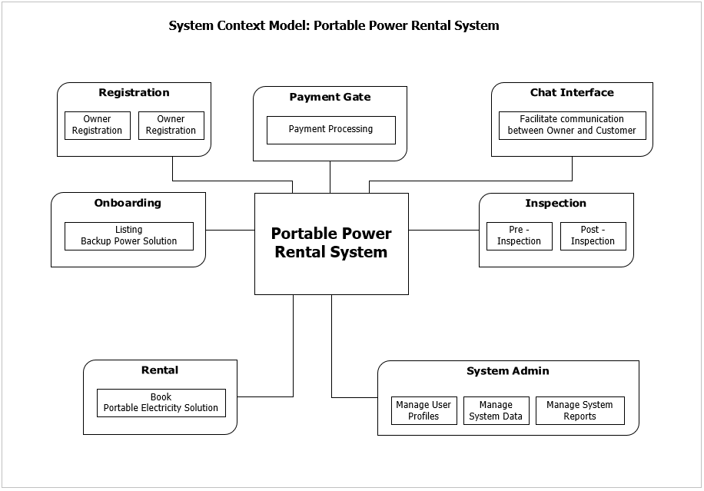

## Product Functionality

Car Rental System provides the features for booking a car online. It includes several functionalities describes as below:

### Registration: Create user profile by registering the backup power Owner and Customer details.

### Rental Management: It provides reservation facility online. Customer can visit the website and check for various backup power solutions to book based on their requirements.

### Payment Gateway: Processes payments related to reservations, cancellations, deposit, and insurance fees for the selected backup power solution.

### Administration: Manages the data on users, system, and reports.

## User Classes and Characteristics

### Customer:

1. Register own details on the system
2. Customer can login to the system
3. Search for available solutions
4. Book a solution for rental
5. Pay for the rental
6. Inspect the condition of the equipment
7. Communicate with system users i.e. Owner
8. Cancel the order

### Owner:

1. Register own details on the system
2. Capture/list power solutions to rent or lease to customers
3. Inspect the condition of the equipment
4. Communicate with system users i.e. Owner
5. Cancel the order

### Admin/Employee:

1. Admin can login to the system.
2. Verify and manage the information captured on the system.
3. Generate price strategy.
4. Handle the payment system.
5. Finalize the order.
6. Cancel the order.

## Functional Requirements

These are statements of services the system should provide, how the system should react to

particular inputs, and how the system should behave in particular situations. It specifies the

application functionality that the developers must build into the product to enable users to

accomplish their tasks.

Table 2: Functional Requirements

| **FR#** | **Required Feature** | **Functions** | **Function Description** |
| --- | --- | --- | --- |
| FR01 | User Login | Single sign-on | Provide a single sign-on if a user is registered as both a portable power owner as well as customer. Access to tab/widget must be based on user type. |
| FR02 | Registration | Register Owner or Customer details | Registration of a Portable Electricity solution owner and customer details |
| FR03 | Portable Power Solution Onboarding | Listing backup power solution | Capturing details required for listing a backup power solution. |
| FR04 | Rental Fee | Generating Rental Price | The system must generate a daily rate once a portable power solution owner inputs all information provided. |
| FR05 | Portable Power Solution Booking | Rent backup power solution to customer | The system must allow the customer to search, and book listed power solutions based on availability. |
| FR06 | Home Screen | Landing Page | The landing page needs to be visible to anyone regardless of whether they have an account or not. |
| FR07 | Payment gateway | Payment Processing | Once a customer has selected a power solution to book, the customer must be directed to the payment gateway provider to process their payment using a debit/credit card |
| FR08 | Chat interface | Chat interface between power solution owner and customer | Chat interface between power solution owner and customer needs to come into effect once a payment has been confirmed. |
| FR09 | Solution  Inspection | Pre and Post inspection of portable power solution | **Pre-inspection:**  Owner (or their proxy?) and customer do a quick inspection of the portable power solution before handover i.e., any dents, scratches etc.  **Post-inspection:**  Both owner (or their proxy?) and customer do a quick post inspection of the portable power solution after usage. |

## System Models

### Use Case

A use-case model describes how different types of users interact with the system to solve a problem. The **use-case diagrams** and **use-case** **narratives** depicted below are defined based on the functional requirements of the system, as such, it describes the goals of the users, the interactions between the users and the system, and the required behaviour of the system in satisfying these goals.

# Use Case Diagram

# Use Case Narrative

**Table 1: Register Owner/Customer details**

|  |  |
| --- | --- |
| Actors | Owner, Customer, Backup system |
| Description | Customer/owner registers by providing their details and passwords, The system verifies using third party and goes to the landing page after the login page. The user/owner enters log in details, The system verifies if the user entered correct log in details. |
| Data | Customer/Owner personal details and passwords. |
| Stimulus | User wants to rent a backup solution. |
| Response | Confirmation that the User/Customer’s details have been saved /updated. |
| comments | The Customer needs to register to be able to rent a solution, The owner needs to register to be able to list backup solutions. |

**Table 2: Listing backup power solutions details**

|  |  |
| --- | --- |
| Actors | Owner, Backup system |
| Description | The owner logins to list backup solutions available and the solution’s details. |
| Data | Portable backup power solutions |
| Stimulus | Owner wants to list their available backup solution for rentals. |
| Response | Confirmation that the portable backup solutions have been saved /updated. |
| comments | The owner needs to login to be able to list backup solutions. |

**Table 3: Generating Rental Price**

|  |  |
| --- | --- |
| Actors | Owner, Backup system |
| Description | The owner generates the prices of the solutions. |
| Data | Portable backup power solution prices. |
| Stimulus | Owner wants to generate prices for the backup solution for rentals. |
| Response | Confirmation that the prices have been updated. |
| comments | The owner needs to login to be able to generate prices of the backup solutions. |

**Table 4: Landing page**

|  |  |
| --- | --- |
| Actors | Customer, Backup system |
| Description | The customer chooses and add to cart the backup solutions they would like to rent for that period. |
| Data | Portable backup solution to be rented. |
| Stimulus | Customer wants to rent a backup solution. |
| Response | The system adds up the total amount of the backup solutions the customer would like to rent for that period and displays the price to the customer. |
| comments | The customer needs to be logged in to be able to do this. |

**Table 5: Payment Processing (Payment Gateway)**

|  |  |
| --- | --- |
| Actors | Customer, Backup system |
| Description | The customer enters their card details to make the payment. |
| Data | Customer’s banking card details and address. |
| Stimulus | Customer wants to rent a backup solution. |
| Response | The system processes the payment and the generates an invoice for the customer. |
| comments | The customer needs to be logged in to be able to do this and provide correct banking details and address. |

**Table 6: Chat Interface**

|  |  |
| --- | --- |
| Actors | Customer, Owner , Backup system |
| Description | The customer communicates and arrange with the owner of the backup solution to schedule an inspection and a pick up point via the chat interface. |
| Data | Customer and Owner’s text messages. |
| Stimulus | Customer wants to inspect the backup solution and get the pick up point. |
| Response | The system confirms time and date of the pick to the customer. |
| comments | The customer needs to be logged in to be able to do this. |

**Table 7: Inspection of Portable Power solution**

|  |  |
| --- | --- |
| Actors | Customer, Owner |
| Description | The customer comes to inspect and collect the backup solution. |
| Data | Customer and Owner’s text messages. |
| Stimulus | Customer wants to inspect the backup solution and collect . |
| Response | The Owner and customer meet up to drop off and pick up the backup solutions. |
| comments |  |

### Entity Relationship Diagram (ERD)

The Entity–Relationship model (ER model) is a data model for describing the data or information aspects of a business domain or its process requirements, in an abstract way that lends itself to ultimately being implemented in a database such as a relational database.

### Non-Functional Requirements

The table below lists the Non-Functional requirements that are related to the development of the new PortablePower Solution.

Table 3: Non-Functional Requirements

|  |  |  |
| --- | --- | --- |
| **NFR#** | **Requirement** | **Description** |
| NFR01 | System accessibility | The System should be web-based, and a user should be able to access the system with their own credentials from anywhere at any time |
| NFR05 | System security | The systems landing page must provide security administration functionality. This must include the following:   * Provide a single sign-on if a user is registered as both a portable power owner as well as customer. Access to tab/widget must be based on user type. * The ability to manage access rights and privileges by individual, group or role. * User identity verification - User is verified through a third-party verification agent. |
| NFR02 | Usability | The system should be user friendly. |
| NFR03 | Capacity/ Scalability | System should ensure enough storage capacity to cater for incremental growth of transaction volumes over the years |
| NFR04 | Data Integrity | Data validation, business and submission rules to be established |
| NFR06 | Hosting Services | The system will be Hosted on the cloud. |
| NFR07 | Audit Trail | The system must be able to show the trail of the transaction or changes made on the system. |
| NFR08 | Performance | The system must be able to handle transactions within the reasonable response time |
| NFR09 | Availability | The system must be available 24/7 to all users |
| NFR10 | Maintainability | Data must be encrypted using open standard technologies |